**EsyPOS**

Installation Guide

<https://codecanyon.net/item/esypos/19271072>

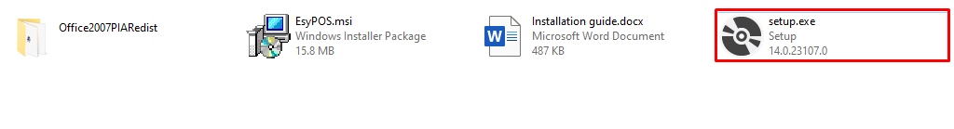

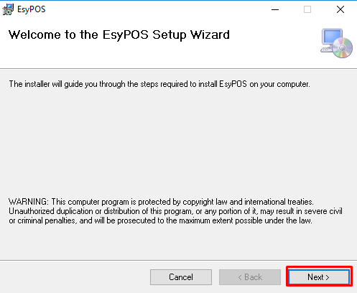

Do not install the software on C Drive because C Drive Read Only Drive. Install the software on another drive. Click **Browse** button.

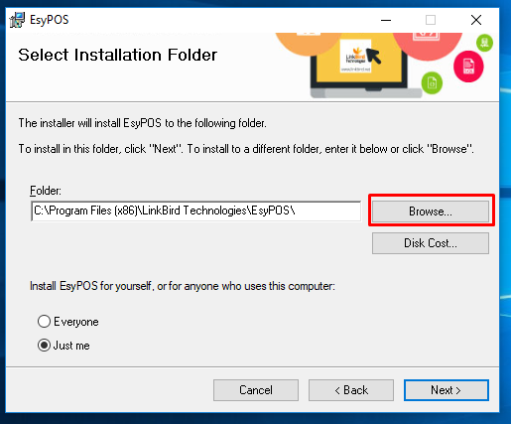

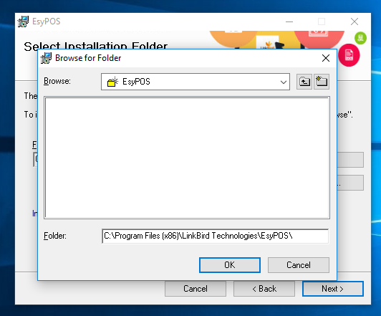

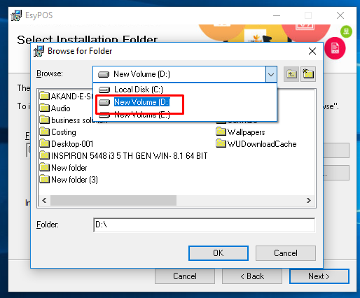

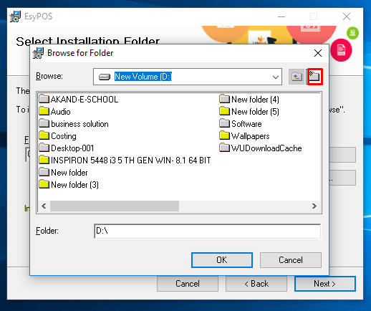

Select another dive and create a new folder named **EsyPOS** and click **OK** button.  And click on the **Next** button.

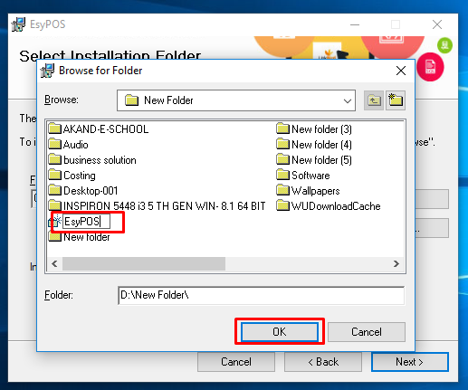

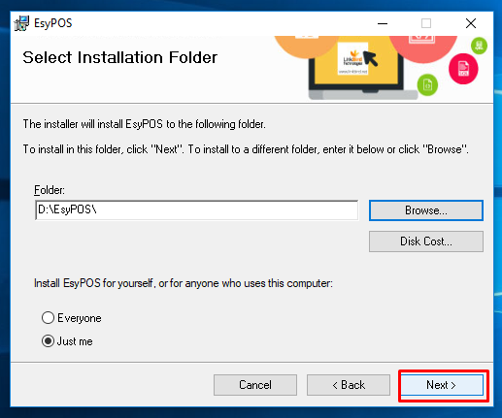

Within a short time the install will end and the icon of EsyPOS will be created on the desktop. Now press the **Close** button.

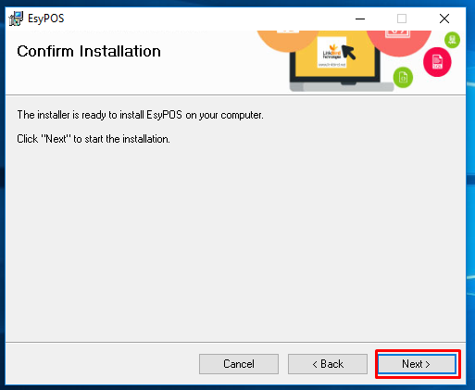

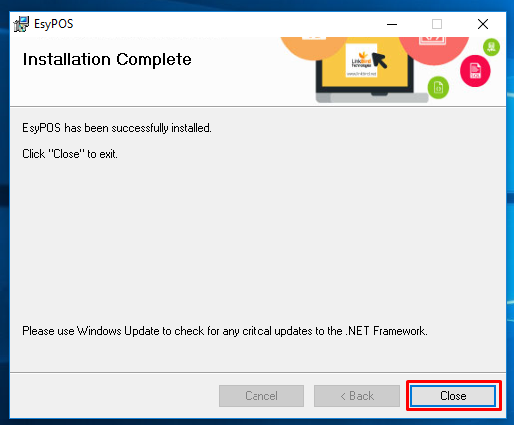



**User name:** superadmin

**Password:** 12345

